STUDY BOT
AI-Powered Study Assistant API
Bootcamp Project Report

Student | Tawanda Ronald Munyanyi
Phone Number | +263772890167
Project Title | Study Bot – AI Study Assistant Bootcamp Project
Technology Stack | FastAPI · LangChain · Groq LLM · MongoDB
Language | Python 3.10+
Date | 21 February 2026

1. Project Overview
StudyBot is an AI-powered chatbot API designed to help students with academic questions across a wide range of subjects including Mathematics, Science, History, Literature, and Programming. Unlike a simple Q&A system, StudyBot maintains conversational context by storing chat history in a MongoDB database, enabling it to provide intelligent, context-aware responses that build on previous exchanges.

The project is built as a RESTful API using FastAPI and integrates the Groq LLM (via LangChain) for fast, high-quality language model responses. Each user session is identified by a unique session ID, allowing multiple students to use the bot simultaneously with their own independent conversation threads.

Core Problem | Students need an always-available, context-aware study assistant
Solution | AI chatbot with persistent memory and academic focus
LLM Provider | Groq (Llama 3 8B model via LangChain)
Memory Store | MongoDB – local or Atlas cloud
API Framework | FastAPI with automatic Swagger documentation

2. Memory Implementation
The core innovation of StudyBot is its database-backed memory system. Instead of relying on in-memory conversation state (which is lost when the server restarts), all messages are persisted to MongoDB. This approach enables true long-term memory and scales naturally to multiple concurrent users.

2.1 How Memory Works
When a user sends a message, the following sequence occurs:
- The API receives the user's message along with their session_id.
- The database module queries MongoDB for all previous messages tied to that session_id.
- The full conversation history is passed to the LLM as context (last 20 messages to stay within token limits).
- The LLM generates a response that is aware of the full conversation.
- Both the user message and bot response are saved to MongoDB for future use.

2.2 MongoDB Document Structure
Each session is stored as a single MongoDB document with the following structure:
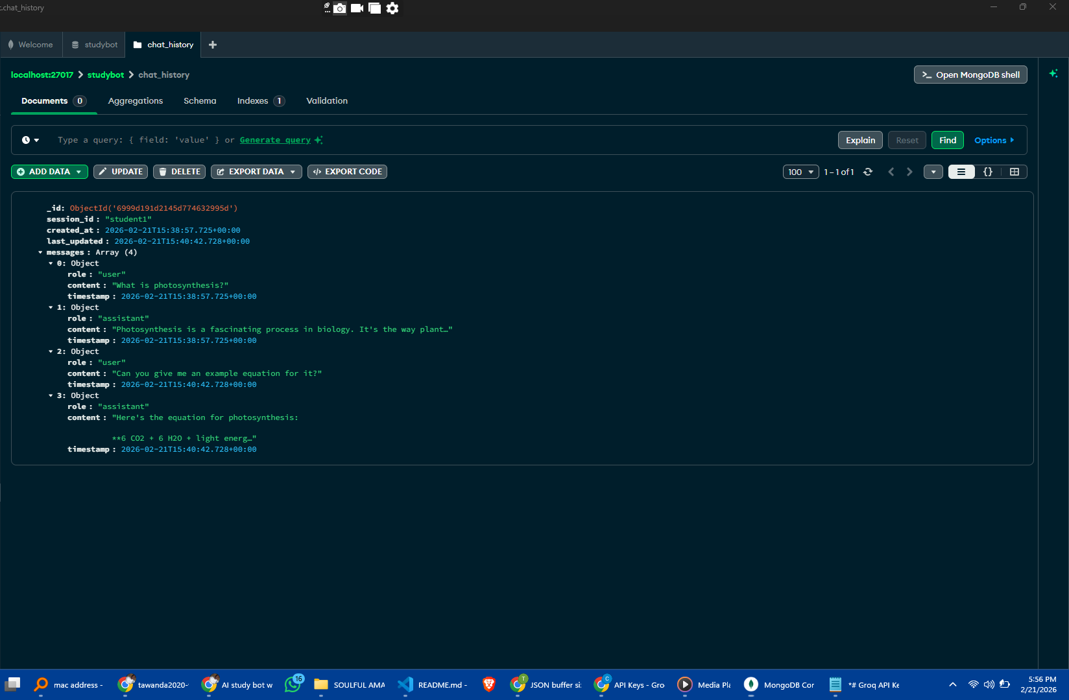

This design stores all messages in a single document per session, making retrieval very efficient — a single find_one() query fetches the complete history. The messages array grows over time, and only the last 20 entries are passed to the LLM to manage token usage.

2.3 Context Window Management
The LLM (Groq Llama 3 8B) has a context window limit. To work within this constraint while still providing meaningful memory, StudyBot implements a sliding window approach — it retrieves the full history from MongoDB but only passes the most recent 20 messages (10 exchanges) to the model. This balances memory depth with performance and cost.

3. System Architecture
StudyBot follows a clean three-layer architecture that separates routing, business logic, and data persistence:

User / Client
|
FastAPI Routes (main.py)
|
| chatbot.py Groq LLM API (via LangChain)
|
|database.py MongoDB (local)

3.1 File Structure

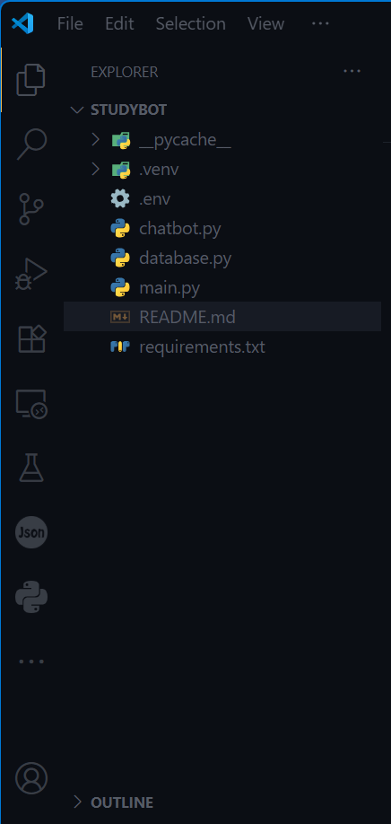

4. API Endpoints

Method | Endpoint | Description
POST | /chat | Send a message and get a context-aware AI response
GET | /history/{session_id} | Retrieve full conversation history for a session
DELETE | /history/{session_id} | Clear all conversation history for a session
GET | / | Health check – confirms API is running
GET | /docs | Swagger UI – interactive API documentation

4.1 Sample Chat Request & Response
Request (POST /chat):
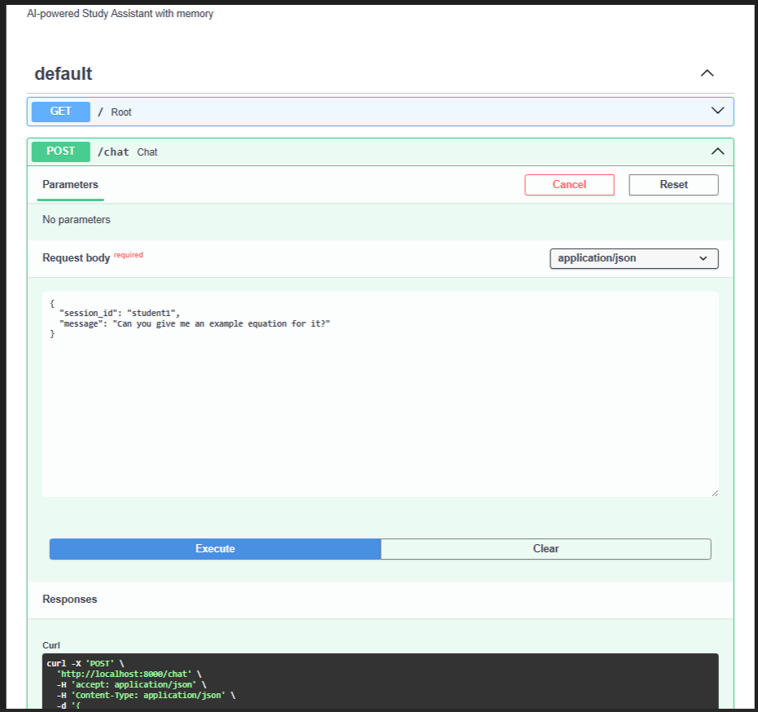

Response:

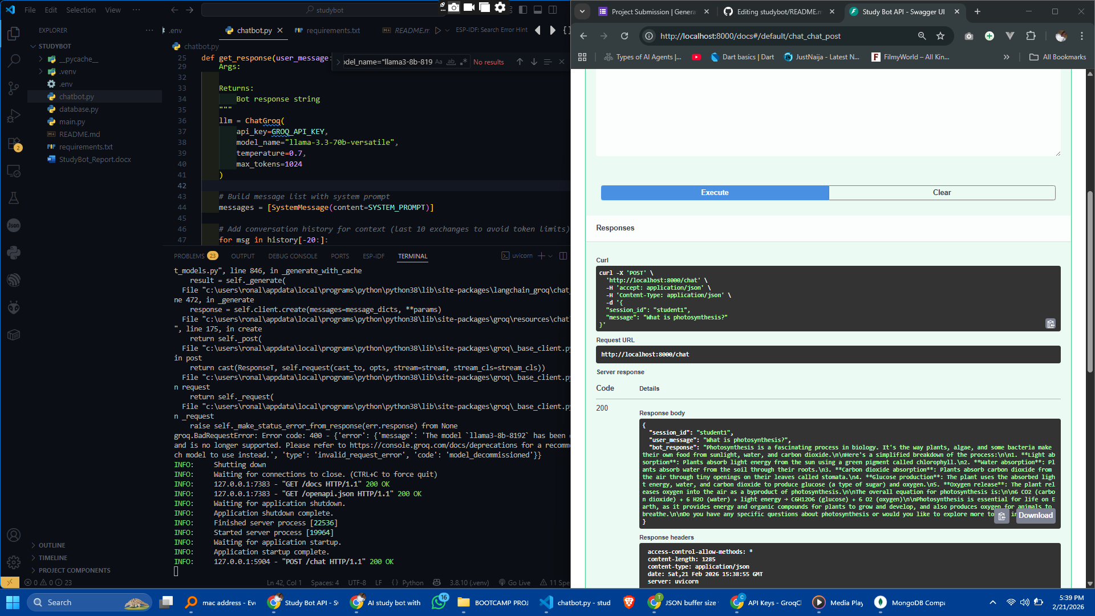

5. Setup & Installation

5.1 Prerequisites
- Python 3.10 or higher
- MongoDB installed locally
- Groq API key – free at https://console.groq.com
- Git (for cloning the repository)

5.2 Step-by-Step Installation
Step 1 – Clone the repository:
Step 2 – Create and activate a virtual environment:
Step 3 – Install dependencies: pip install -r requirements.txt
Step 4 – Configure environment variables:
Step 5 – Start MongoDB (local):
Step 6 – Run the application:
The API is now live at http://localhost:8000 and the interactive docs are at http://localhost:8000/docs.

6. Project Links

GitHub Repository | https://github.com/tawanda2020-wq/studybot

8. Sample API Test Screenshots
Below are placeholders for API test screenshots. Add these after running the application:

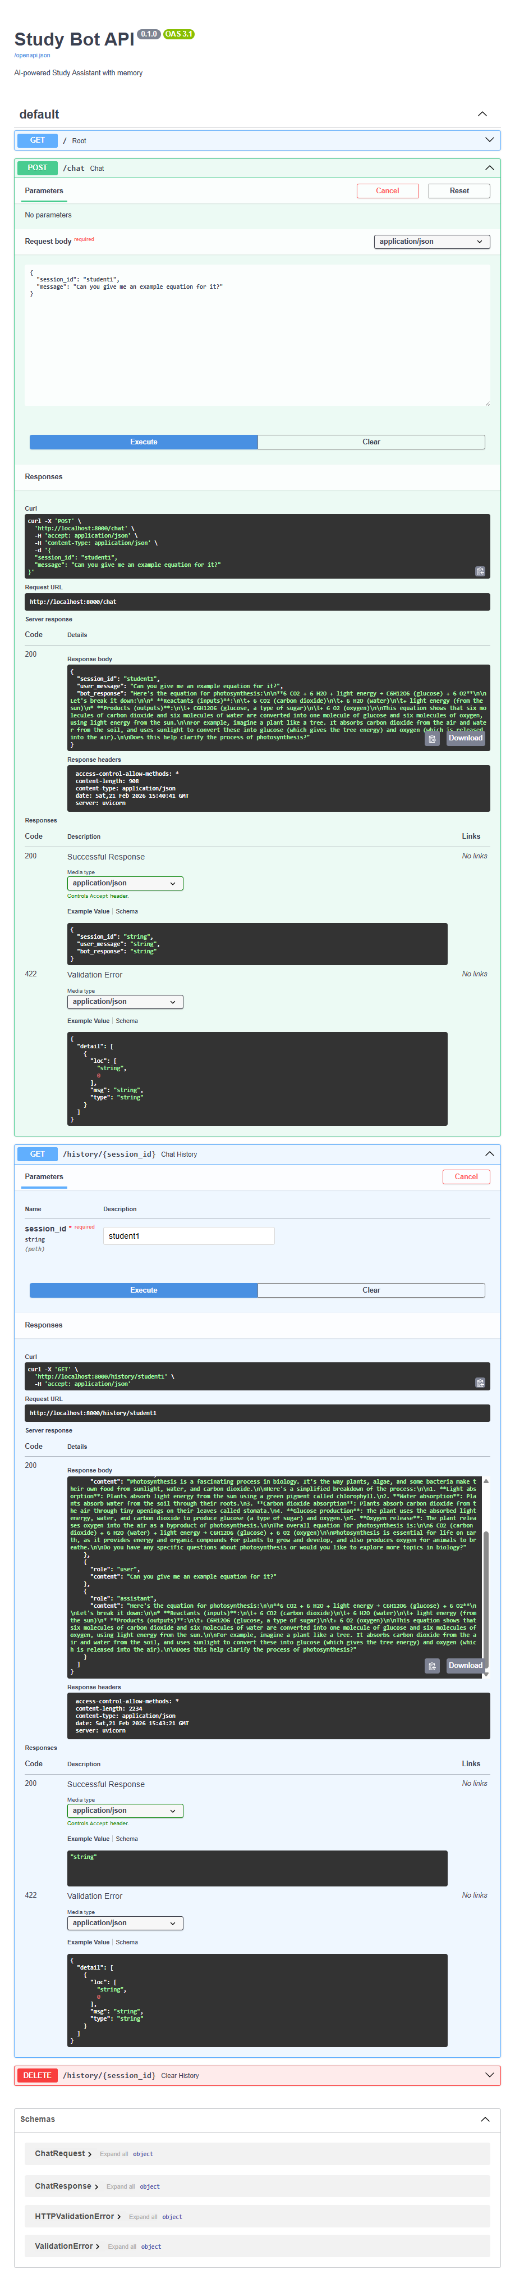

9. Conclusion
StudyBot demonstrates a complete production-grade pattern for building AI-powered applications with persistent memory.

